PYTHON-1

1. What is Python?
Python is a popular programming language. It was created by Guido van Rossum, and released in 1991.
It is used for:
- web development (server-side),
- software development,
- mathematics,
- system scripting.

A High-Level Language
Python falls under the category of high-level, interpreted languages. A high-level language is one which cannot be understood directly by our machine. There is a certain degree of abstraction in its syntax. Machines are generally designed to read machine code, but high-level syntax cannot be directly converted to machine code.
As a result, it must first be converted to bytecode which is then converted to machine code before the program can be executed.
Python is an interpreted language because, during execution, each line is interpreted to the machine language on-the-go.
However, if we take the example of C++, the code needs to be compiled into an executable first, and then it can be executed. In Python, we can skip this compilation step (Python does it for us behind the scenes) and directly run the code.

Readability
One of the biggest reasons for Python’s rapid growth is the simplicity of its syntax. The language reads almost like plain English, making it easy to write complex programs.
Since it doesn’t have much of a learning curve, Python is a very good entry point into the world of programming for beginners.

Applications
Apart from the ease of learning, Python is a very efficient language which is used in almost every sphere of modern computing.
This makes a strong case for learning Python, even for non-programmers.
Some of Python’s main applications are highlighted below:

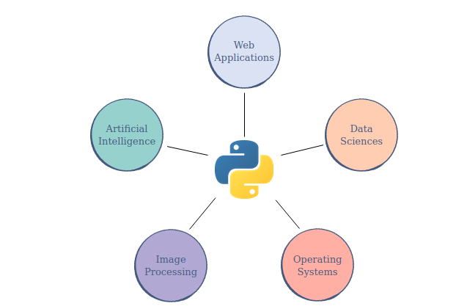
.

2. Python Interpreter

The Python interpreter is a program that executes Python code. It is the core component of the Python programming language that reads and interprets Python source code files (with the .py extension) and executes the instructions written in those files.

When you run a Python script or type Python code interactively in the Python shell, the Python interpreter reads the code line by line, compiles it into bytecode, and then executes that bytecode. It is responsible for translating human-readable Python code into machine-executable instructions that the computer's CPU can understand and execute.

3. Latest Version Of Python
Latest version of python: 3.x or 3.11

4. Python 2 vs Python 3

- Python 2 was launched in 2000; Python 3 was launched in 2008.
- Python 2 considers the “print” keyword a statement; Python 3 considers “print” a function.
- Python 2 stores strings by ASCII; Python 3 uses Unicode.
- Python 2 has a more complex syntax than Python 3.
- Many Python 2 libraries aren’t forward compatible; many libraries exclusively use Python 3.
- Python discontinued Python 2 support in January 2020; Python 3 remains the most popular choice.

5. How Does Python works:
You write your Python code in a text file with a '.py' extension. This file contains the source code of your program,The Python interpreter starts by reading the source code from the '.py' file.The Python interpreter then converts it into an intermediate representation called bytecode. Bytecode is a low-level, platform-independent representation of the program's logic. It is not executed directly by the CPU but rather by the Python Virtual Machine (PVM).The PVM is responsible for interpreting the bytecode and executing the program.

6. Python Syntax

- Python was designed for readability, and has some similarities to the English language with influence from mathematics.
- Python uses new lines to complete a command, as opposed to other programming languages which often use semicolons or parentheses.
- Python relies on indentation, using whitespace, to define scope; such as the scope of loops, functions and classes. Other programming languages often use curly-brackets for this purpose.

7. Python Installation:
1. sudo apt update
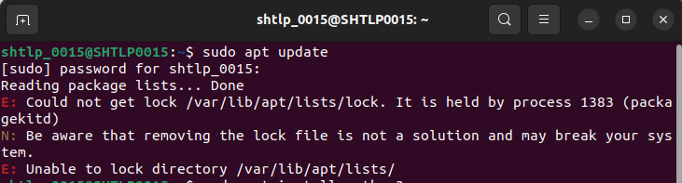
2. sudo apt install python3

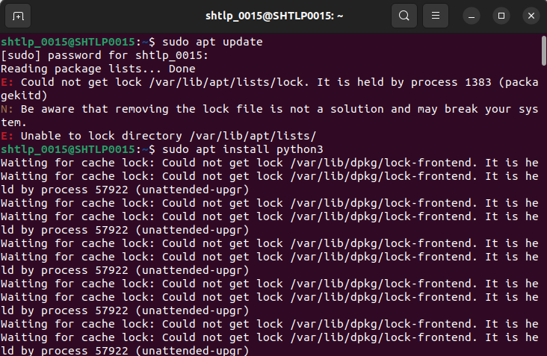
.

3. python3 –version : to check which pyhton is version installed

8. The print Statement
Since Python is one of the most readable languages out there, we can print data on the terminal by simply using the print statement.
Here’s what the statement looks like:

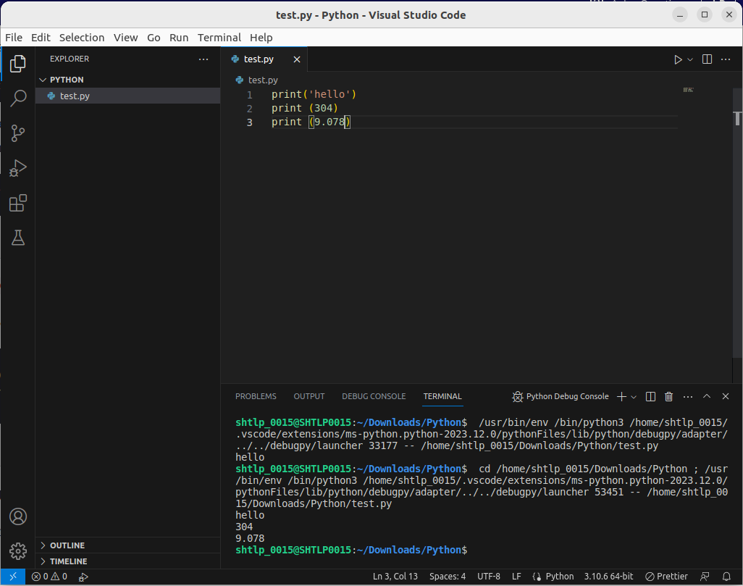
.

Printing Multiple Pieces of Data
We can even print multiple things in a single print command; we just have to separate them using commas.
end=’’’
By default, each print statement prints text in a new line. If we want multiple print statements to print in the same line, we can use end=””
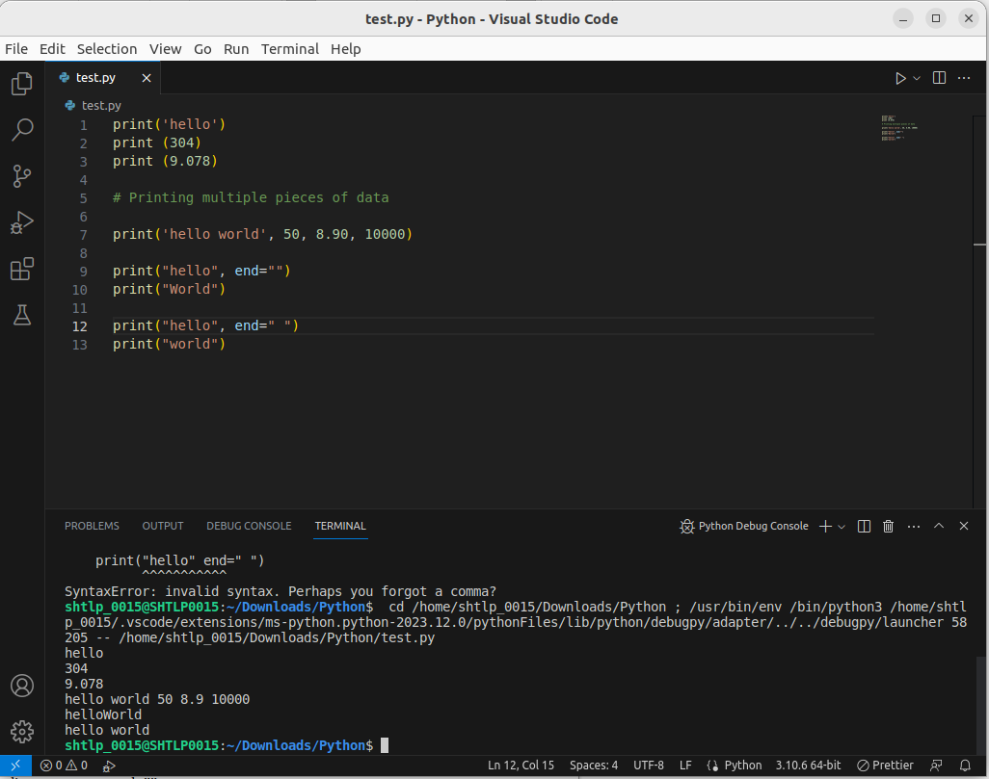
.

9. Python Comments
Comments are pieces of text used to describe what is happening in the code. They have no effect on the code whatsoever.
A comment can be written using the # character.

- Comments can be used to explain Python code.
- Comments can be used to make the code more readable.
- Comments can be used to prevent execution when testing code.

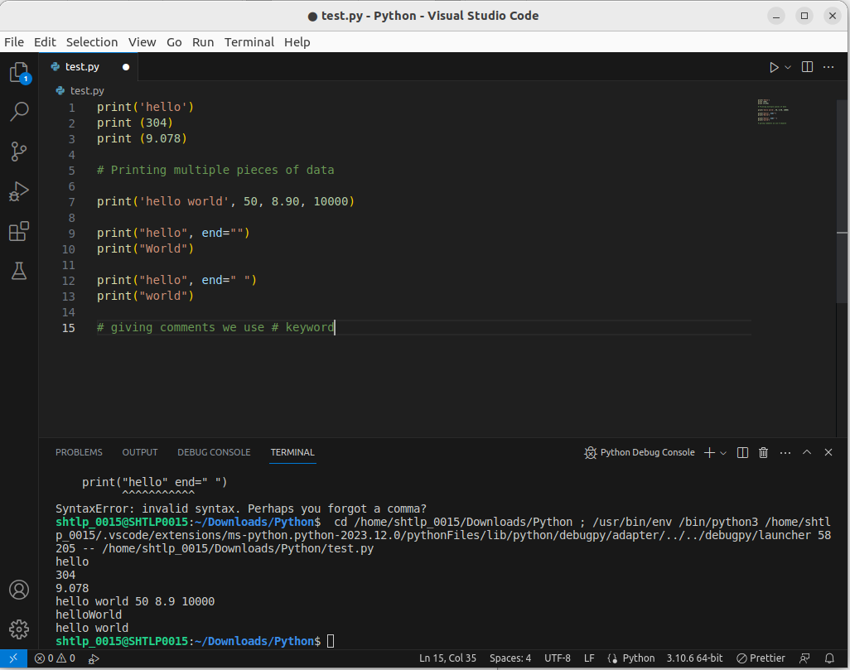
.

Multi Line Comments
An alternative to these multi-line comments (line 4 - 8) are docstrings. They are encased in triple quotes, """, and can be used to replace multi-line comments:

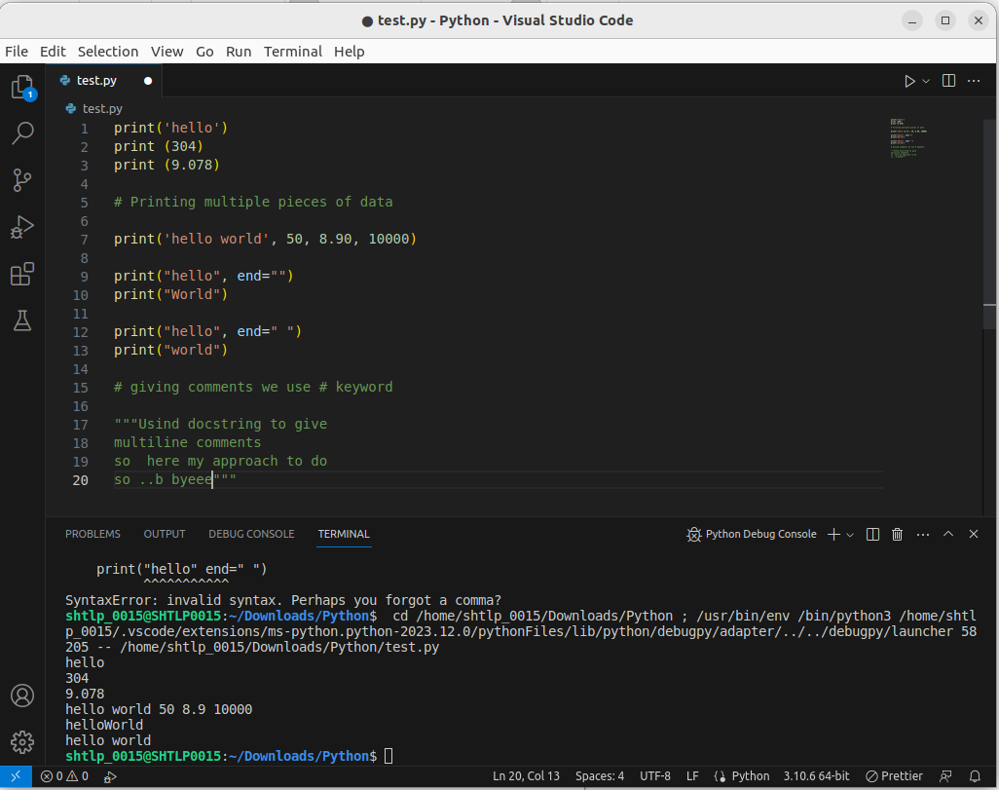

10. Python Indentation
Indentation refers to the spaces at the beginning of a code line.
Where in other programming languages the indentation in code is for readability only, the indentation in Python is very important.
Python uses indentation to indicate a block of code.
You have to use the same number of spaces in the same block of code, otherwise Python will give you an error:
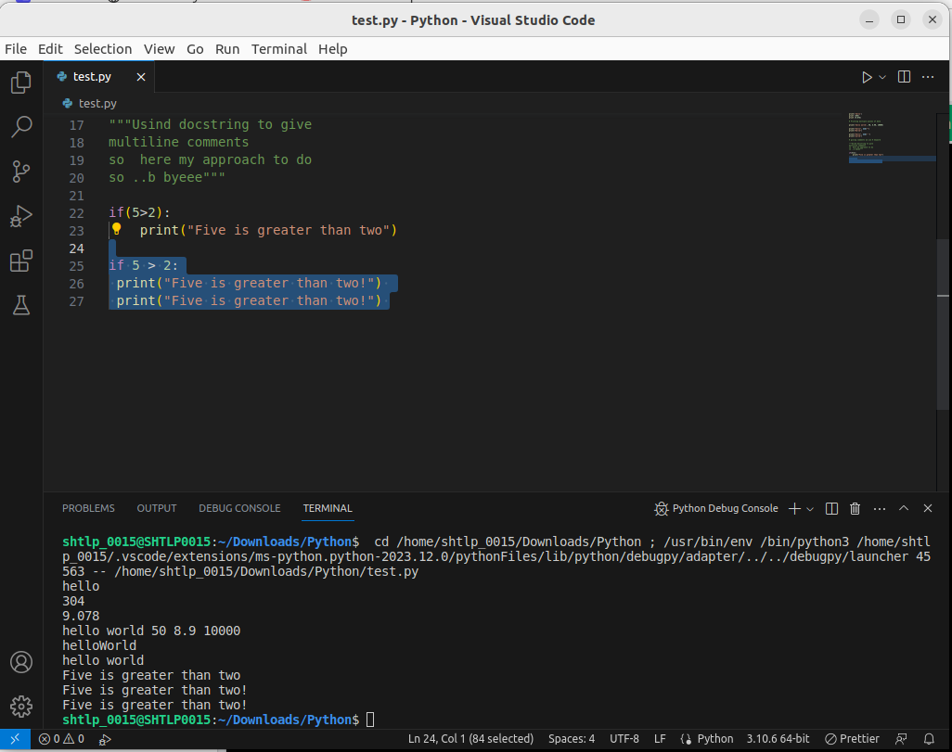

11. Python Variables
In Python, variables are created when you assign a value to it:
Python has no command for declaring a variable.

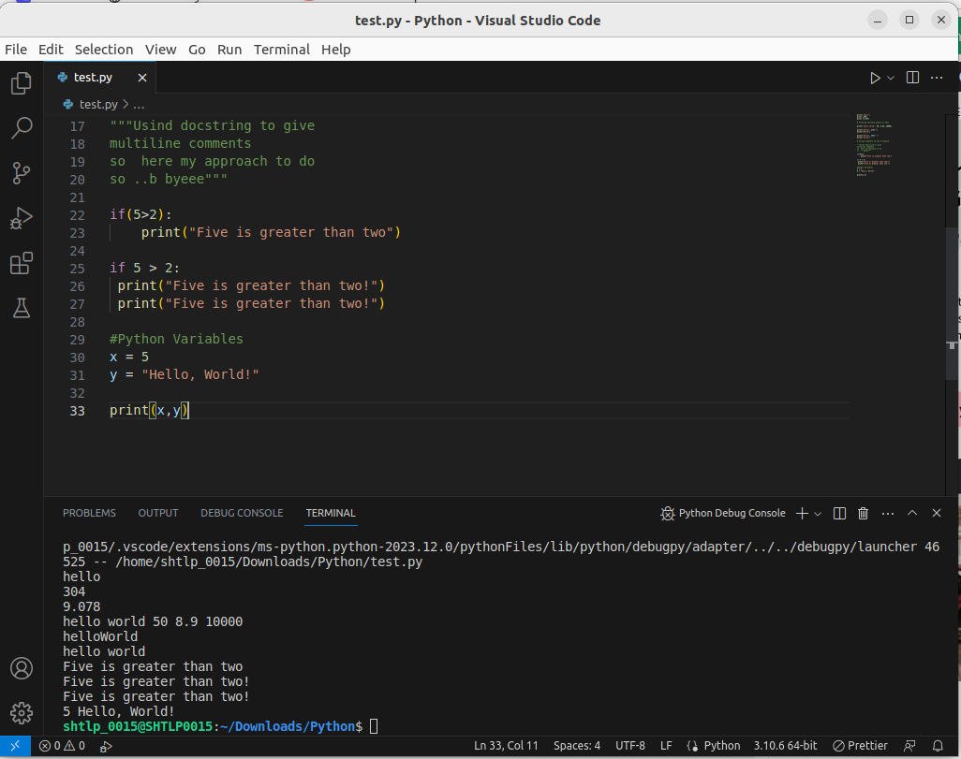
.

Python - Variable Names

Variable Names
A variable can have a short name (like x and y) or a more descriptive name (age, carname, total_volume). Rules for Python variables:
- A variable name must start with a letter or the underscore character
- A variable name cannot start with a number
- A variable name can only contain alpha-numeric characters and underscores (A-z, 0-9, and _ )
- Variable names are case-sensitive (age, Age and AGE are three different variables)
- A variable name cannot be any of the Python keywords.
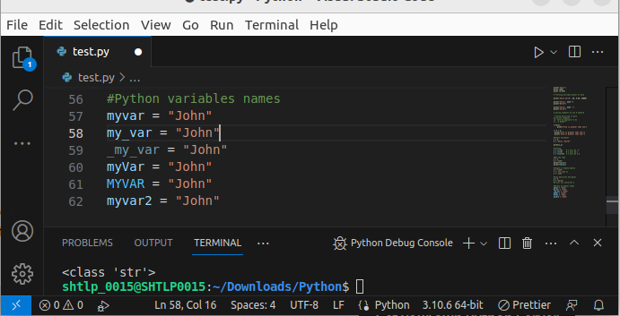

Multi Words Variable Names
Variable names with more than one word can be difficult to read.
There are several techniques you can use to make them more readable:

Camel Case
Each word, except the first, starts with a capital letter:
myVariableName = "John"

Pascal Case
Each word starts with a capital letter:
MyVariableName = "John"

Snake Case
Each word is separated by an underscore character:
my_variable_name = "John"

Python Variables - Assign Multiple Values

Many Values to Multiple Variables
Python allows you to assign values to multiple variables in one line:
Note: Make sure the number of variables matches the number of values, or else you will get an error.
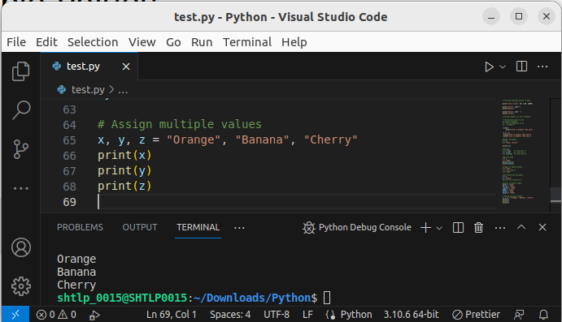

One Value to Multiple Variables
And you can assign the same value to multiple variables in one line:
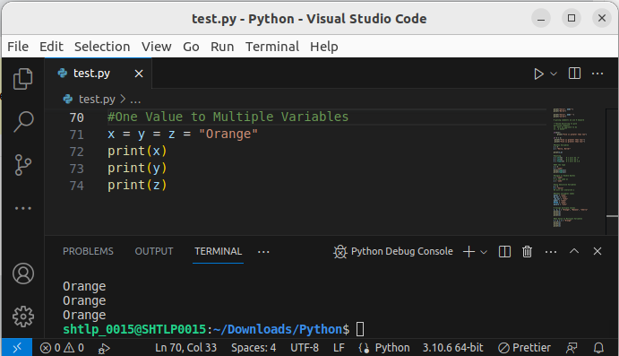

Unpack a Collection
If you have a collection of values in a list, tuple etc. Python allows you to extract the values into variables. This is called unpacking.
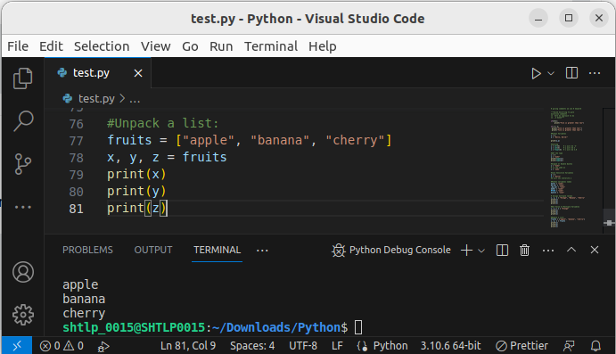
.

Python - Output Variables

Output Variables
The Python print() function is often used to output variables.
In the print() function, you output multiple variables, separated by a comma:
You can also use the + operator to output multiple variables:
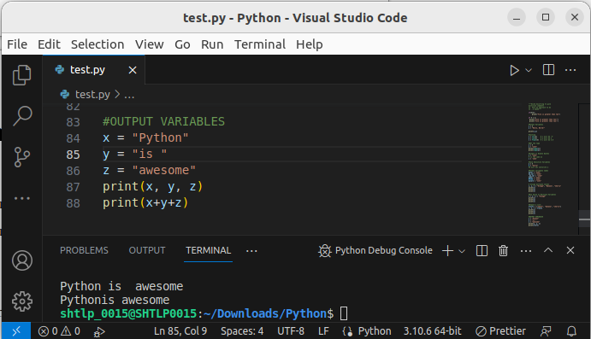
.
For numbers, the + character works as a mathematical operator:
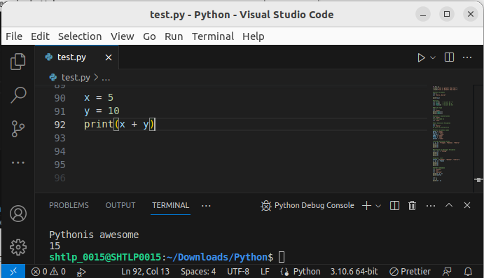

Python - Global Variables

Global Variables:
Variables that are created outside of a function (as in all of the examples above) are known as global variables.
Global variables can be used by everyone, both inside of functions and outside.

If you create a variable with the same name inside a function, this variable will be local, and can only be used inside the function. The global variable with the same name will remain as it was, global and with the original value.
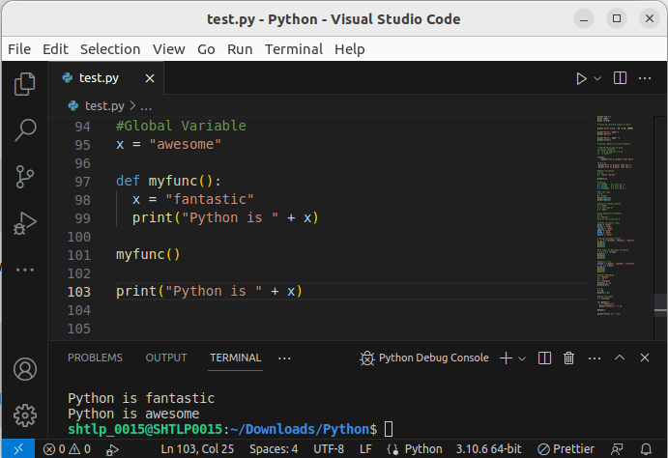

Casting
If you want to specify the data type of a variable, this can be done with casting.
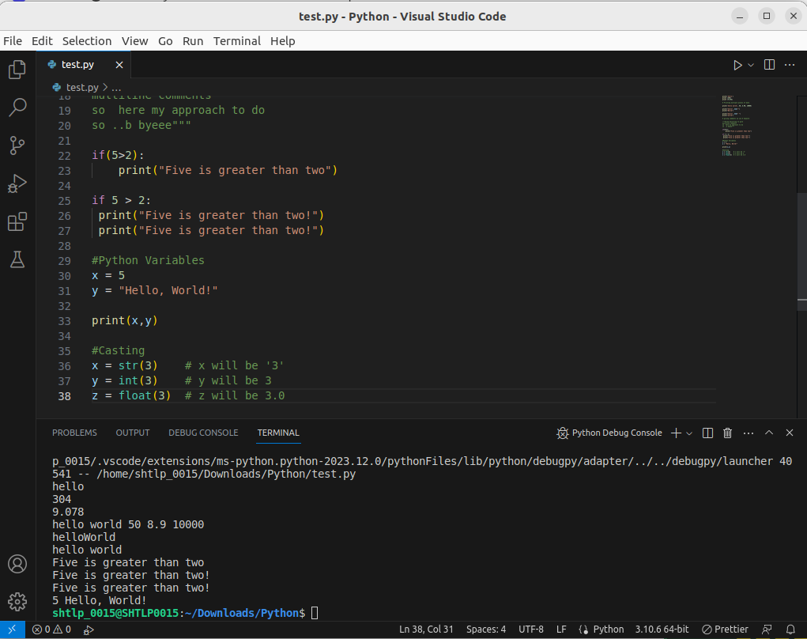

12. Get the Type (type())
You can get the data type of a variable with the type() function.
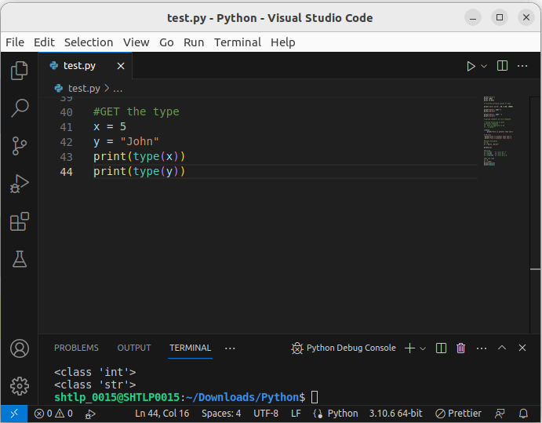

Single or Double Quotes?
String variables can be declared either by using single or double quotes:

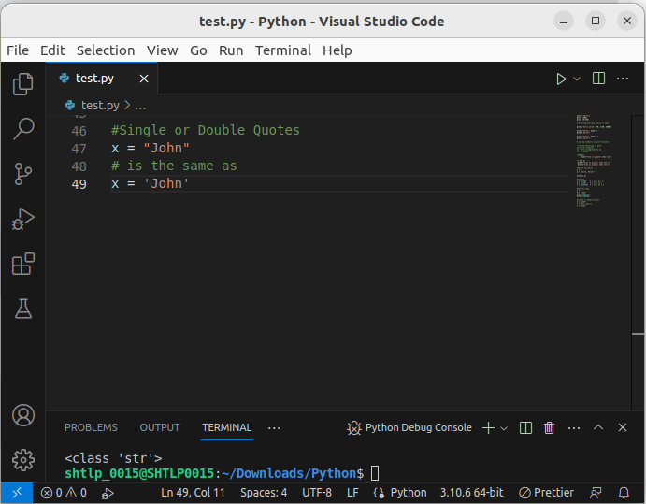
.

Case-Sensitive
Variable names are case-sensitive.
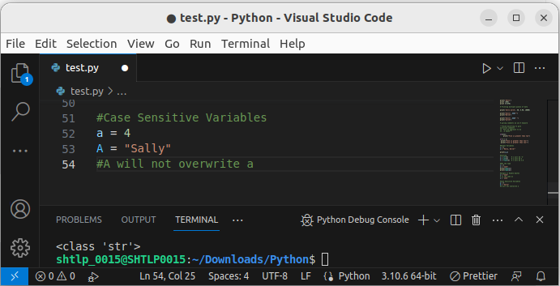

13. The global Keyword
Normally, when you create a variable inside a function, that variable is local, and can only be used inside that function.
To create a global variable inside a function, you can use the global keyword.
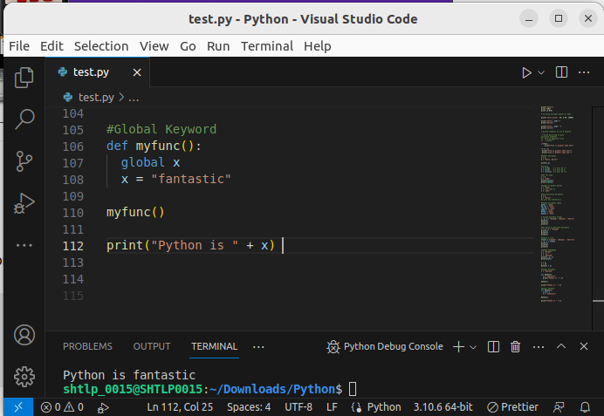
.
Also, use the global keyword if you want to change a global variable inside a function.
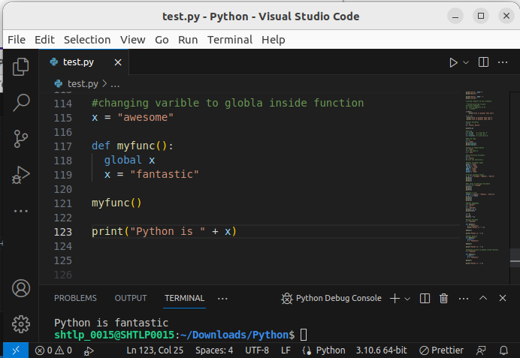

14. What are Data Types and Variables?

Built-in Data Types
In programming, data type is an important concept.
Variables can store data of different types, and different types can do different things.
Python has the following data types built-in by default, in these categories:
Text Type: | str
Numeric Types: | int, float, complex
Sequence Types: | list, tuple, range
Mapping Type: | dict
Set Types: | set, frozenset
Boolean Type: | bool
Binary Types: | bytes, bytearray, memoryview
None Type: | NoneType

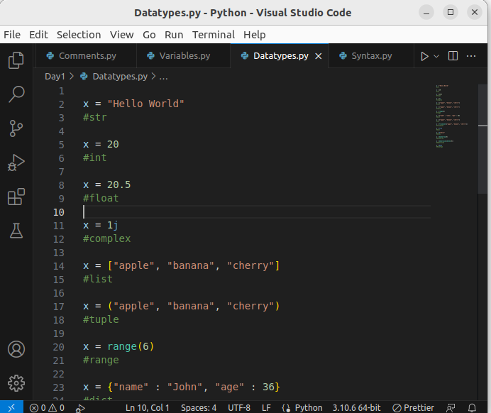
.

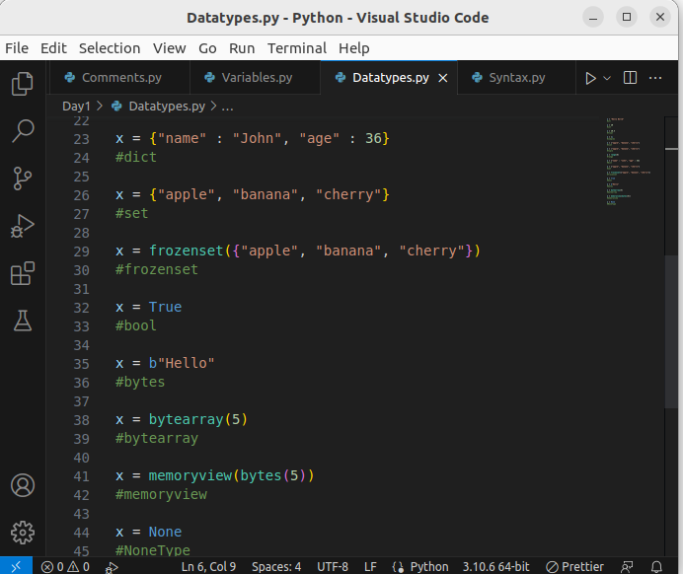
.

15. Python Numbers
There are three numeric types in Python:
- int
- float
- complex
Variables of numeric types are created when you assign a value to them:

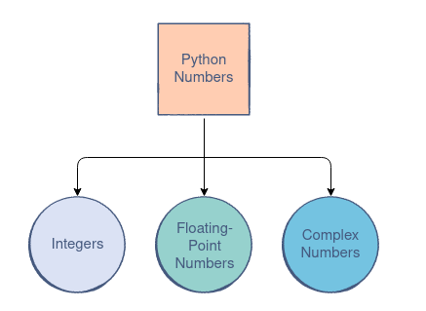

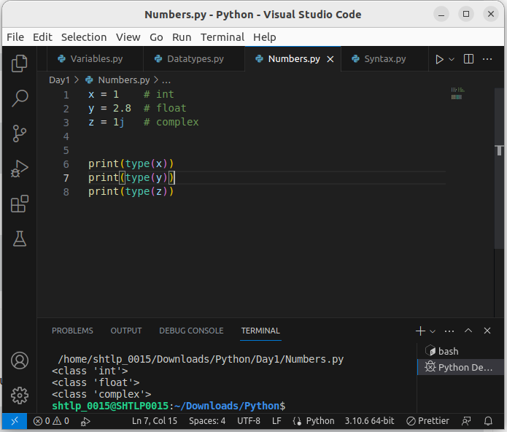
.

Int
Int, or integer, is a whole number, positive or negative, without decimals, of unlimited length.
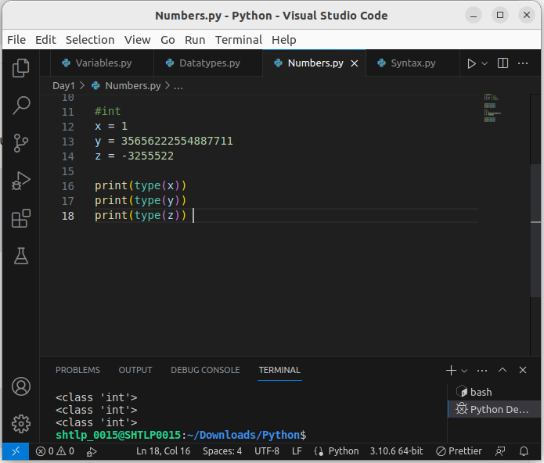
.

Float
Float, or "floating point number" is a number, positive or negative, containing one or more decimals.
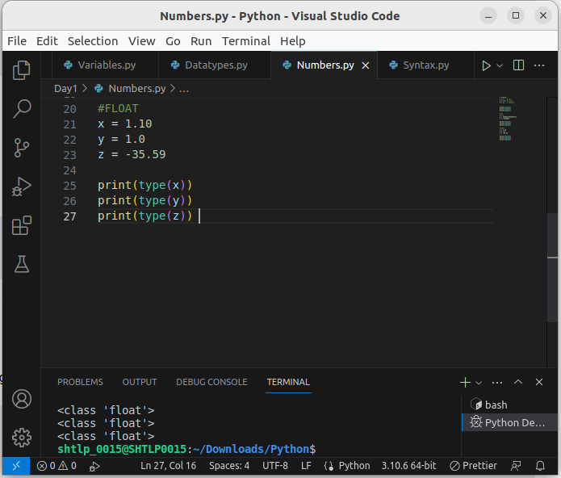
.

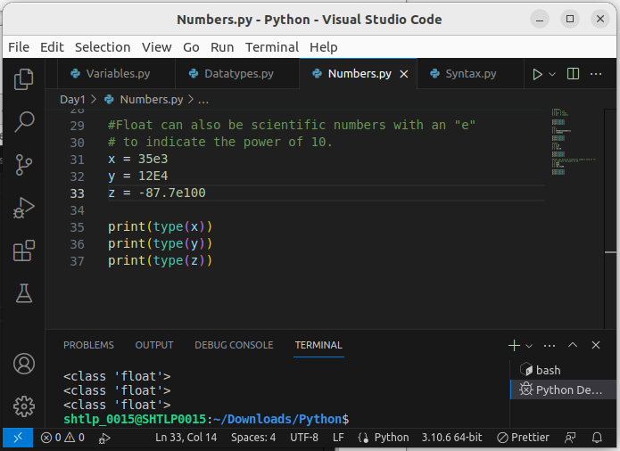
.

Complex
Complex numbers are written with a "j" as the imaginary part:

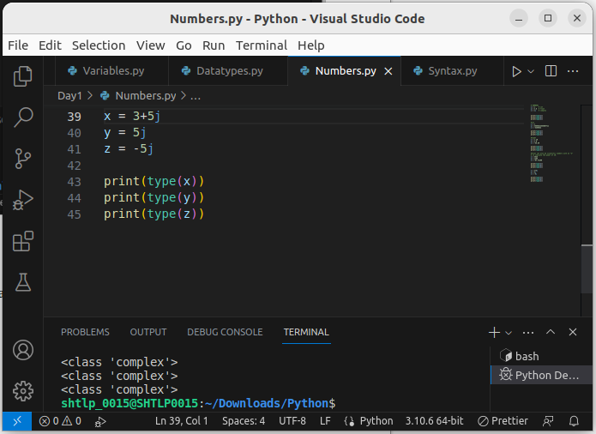
/.

Type Conversion
You can convert from one type to another with the int(), float(), and complex() methods:
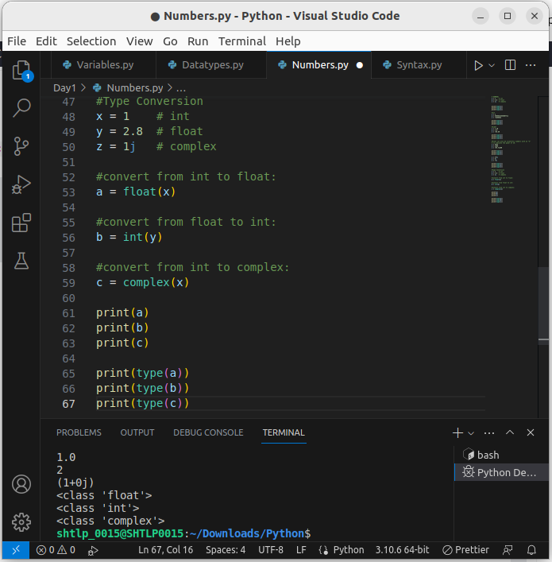
.

16. Random Number
Python does not have a random() function to make a random number, but Python has a built-in module called random that can be used to make random numbers:
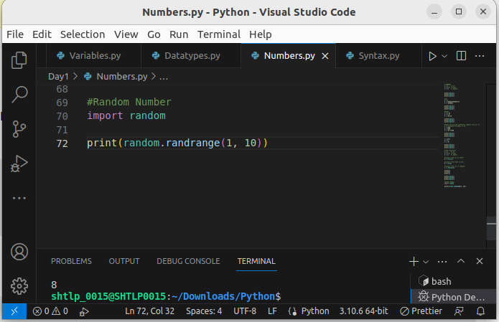
.

17. Expression vs Statement in Python
In Python, a statement is a complete line of code that performs an action, such as assigning a value to a variable or defining a function. On the other hand, an expression is a combination of literals, variables, operators, and function calls that evaluates to a single value.
In this line, the value 10 is assigned to the variable "x." This is a statement because it performs an action (assignment).
1. Statement:
x = 10
In this line, the value 10 is assigned to the variable "x." This is a statement because it performs an action (assignment).
2. Expression:
y = 2 * (x + 5)
In this line, the expression `(x + 5)` is evaluated first, resulting in a value. Then, `2 * (x + 5)` calculates a final value, which is assigned to the variable "y." The expression calculates a value but doesn't perform any action on its own.
A statement is a line of code that performs an action, while an expression is a combination of values and operations that results in a single value.

